LAB EXPERIMENTS
Name:Gopika J Reg No: 192324032

Experiment – 8
import pandas as pd

# Create DataFrame
sales_data = {
"OrderDate":["1-6-18","1-23-18","2-9-18","2-26-18","3-15-18","4-1-18","4-18-18",
"5-5-18","5-22-18","6-8-18","6-25-18","7-12-18","7-29-18",
"8-15-18","9-1-18","9-18-18","10-5-18","10-22-18"],

"Region":["East","Central","Central","Central","West","East","Central",
"Central","West","East","Central","East","East","East",
"Central","East","Central","East"],

"Manager":["Martha","Hermann","Hermann","Timothy","Timothy","Martha","Martha",
"Hermann","Douglas","Martha","Hermann","Martha","Douglas",
"Martha","Douglas","Martha","Hermann","Martha"],

"SalesMan":["Alexander","Shelli","Luis","David","Stephen","Alexander",
"Steven","Luis","Michael","Alexander","Sigal","Diana",
"Karen","Alexander","John","Alexander","Sigal","Alexander"],

"Item":["Television","Home Theater","Television","Cell Phone","Television",
"Home Theater","Television","Television","Television",
"Home Theater","Television","Home Theater","Home Theater",
"Television","Desk","Video Games","Home Theater","Cell Phone"],

"Units":[95,50,36,27,56,60,75,90,32,60,90,29,81,35,2,16,28,64],

"Unit_price":[1198,500,1198,225,1198,500,1198,1198,1198,
500,1198,500,500,1198,125,58.5,500,225]
}

df = pd.DataFrame(sales_data)

df["Sale_amt"] = df["Units"] * df["Unit_price"]

# Pivot Table
pivot = pd.pivot_table(df,
index="Item",
values="Units",
aggfunc="sum")

print("Item-wise Units Sold")
print(pivot)

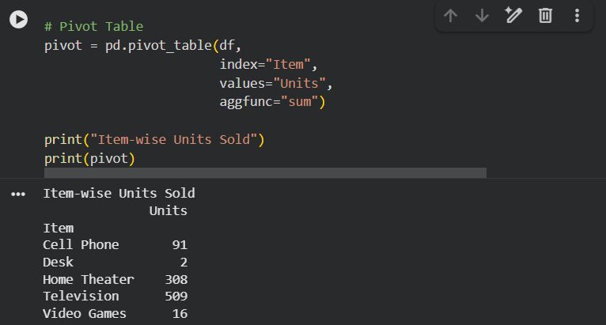
EXPERIMENT -9
import pandas as pd

# Create DataFrame
sales_data = {
"OrderDate":["1-6-18","1-23-18","2-9-18","2-26-18","3-15-18","4-1-18","4-18-18",
"5-5-18","5-22-18","6-8-18","6-25-18","7-12-18","7-29-18",
"8-15-18","9-1-18","9-18-18","10-5-18","10-22-18"],

"Region":["East","Central","Central","Central","West","East","Central",
"Central","West","East","Central","East","East","East",
"Central","East","Central","East"],

"Manager":["Martha","Hermann","Hermann","Timothy","Timothy","Martha","Martha",
"Hermann","Douglas","Martha","Hermann","Martha","Douglas",
"Martha","Douglas","Martha","Hermann","Martha"],

"SalesMan":["Alexander","Shelli","Luis","David","Stephen","Alexander",
"Steven","Luis","Michael","Alexander","Sigal","Diana",
"Karen","Alexander","John","Alexander","Sigal","Alexander"],

"Item":["Television","Home Theater","Television","Cell Phone","Television",
"Home Theater","Television","Television","Television",
"Home Theater","Television","Home Theater","Home Theater",
"Television","Desk","Video Games","Home Theater","Cell Phone"],

"Units":[95,50,36,27,56,60,75,90,32,60,90,29,81,35,2,16,28,64],

"Unit_price":[1198,500,1198,225,1198,500,1198,1198,1198,
500,1198,500,500,1198,125,58.5,500,225]
}

df = pd.DataFrame(sales_data)

df["Sale_amt"] = df["Units"] * df["Unit_price"]

# Pivot Table
pivot = pd.pivot_table(df,
index=["Region","Manager","SalesMan"],
values="Sale_amt",
aggfunc="sum")

print("Region-wise, Manager-wise, Salesman-wise Total Sales")
print(pivot)
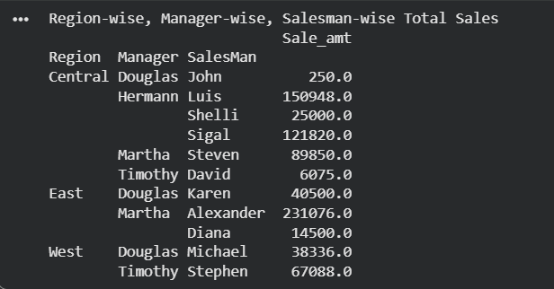

Experiment - 10
import pandas as pd
import numpy as np

# Generate random data
np.random.seed(10)

df = pd.DataFrame(
np.random.randint(-50,51,size=(10,4)),
columns=["A","B","C","D"]
)

print(df)

# Function for coloring
def color_numbers(val):
if val < 0:
return "color:red"
else:
return "color:black"

# Display styled dataframe
df.style.applymap(color_numbers)
